Docker for DevOps – Scenario-Based Practical Assignment

Scenario 1: Container Crash in Staging (Troubleshooting Focus)

Tasks 1. The team says: “The container keeps restarting.”

a) List the exact Docker commands you will run first to see the container status and recent restart history (at least 3 commands). Explain in one line what you expect from each.

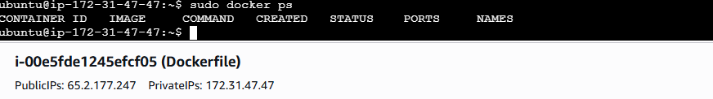

sudo docker ps -a
sudo docker logs coffee-api-stg
sudo docker inspect coffee-api-stg

b) Use appropriate docker logs options (flags) to see only the latest crash output and follow logs live. Write the full command(s)

docker logs --tail 20 coffee-api-stg
docker logs --tail 20 -f coffee-api-stg

2. You discover the app is failing due to a missing environment variable DB_HOST.

a) Show how you will confirm which environment variables the container was started with, using Docker CLI.

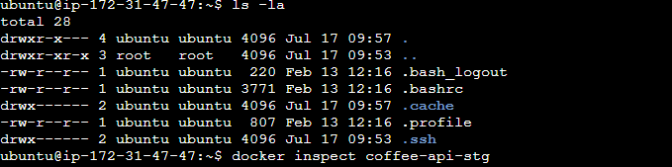
docker inspect coffee-api-stg
docker exec -it coffee-api-stg env

b) Write the corrected docker run command that sets DB_HOST=dbstaging (assume image org/coffee-api:1.2, container name coffeeapi-stg, mapping host port 8080 to container port 3000).

docker run -d --name coffee-api-stg -e DB_HOST=db-staging -p 8080:3000 org/coffee-api:1.2
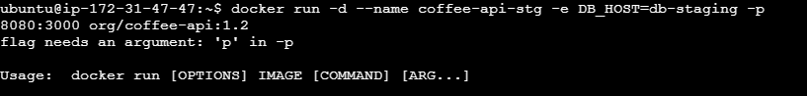

3. After fixing DB_HOST, the container still fails. You suspect a port conflict (port 8080 already in use on host).

a) Explain how you will confirm whether port 8080 is already in use by another container, using Docker commands only.

docker ps
docker port <container-name>

b) Provide a new docker run command that avoids the conflict by using a different host port (keep the container port 3000 unchanged).

docker run -d --name coffee-api-stg -e DB_HOST=db-staging -p 8081:3000 org/coffee-api:1.2

Scenario 2: Containerizing a Legacy Python App (Image Build & Optimization)
Your team has a legacy Flask app:

• Entry file: app.py
• Runs with: python app.py
• Uses requirements.txt
• Needs environment variable APP_ENV (dev, staging, prod)
• Listens on port 5000 internally
You must containerize this app and prepare it for CI/CD use.

Tasks
4. Write a complete Dockerfile that:
• Uses an official Python base image.
• Installs dependencies efficiently (respecting layer cache).
• Sets a default APP_ENV=dev but allows override at runtime.
• Exposes the correct port and runs the app.

5. Your image is now over 1 GB and slowing down pushes.

a) Modify the Dockerfile (or describe the changes) to significantly reduce size using at least two techniques (for example: slim/alpine images, removing build tools, multi-stage builds).

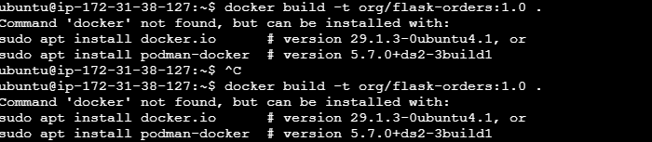

# Use official Python image
FROM python:3.11-slim

# Set working directory
WORKDIR /app

# Copy dependency file first
COPY requirements.txt .

# Install dependencies
RUN pip install --no-cache-dir -r requirements.txt

# Copy application files
COPY . .

# Default environment variable
ENV APP_ENV=dev

# Expose Flask port
EXPOSE 5000

# Run the application
CMD ["python", "app.py"]

• b) Explain in 3–4 lines how Docker layer caching works and how changing the order of Dockerfile instructions can affect build times.

Docker builds images in layers. If a layer has not changed since the last build, Docker reuses the cached layer instead of rebuilding it. By copying the application source, dependency installation is cached and only reruns when dependencies change. Placing frequently changing files later in the Dockerfile results in faster rebuilds.

6. You need to test the image locally.
a) Provide the docker build command to build this image with tag org/flask-orders:1.0.

docker build -t org/flask-orders:1.0 .

• b) Provide the docker run command to start it in staging mode, mapping host port 8081 to container port 5000, and set APP_ENV=staging.

docker run -d --name flask-orders -p 5000:5000 -e APP_ENV=staging org/flask-orders:1.0

Scenario 3: Web + Database Stack with Docker Compose

A new microservice called Coffee Orders will be developed. The stack:

• orders-api (Node.js) – listens on port 3000 inside container
• orders-db (MySQL) – data must persist; only API should talk to DB
• Developers want to run everything locally with one command

You decide to use Docker Compose.
Tasks

7. Create a docker-compose.yml that:

• Defines two services: orders-api and orders-db.
• Uses a MySQL image (e.g. mysql:8) with environment variables configured for root password and database name.
• Mounts a named volume for MySQL data persistence.
• Exposes orders-api on host port 8082 but does not expose MySQL to host directly.
• Ensures both services are on a custom user-defined network.

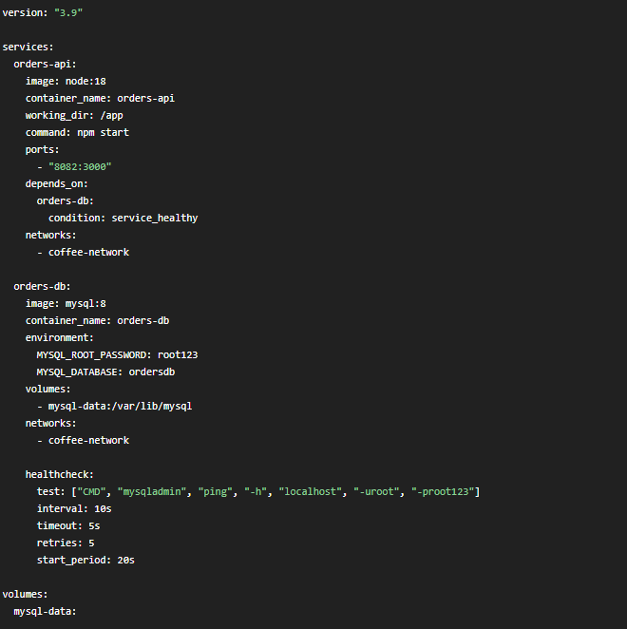

orders-api:Defines the Node.js API service that listens on port 3000 inside the container and is exposed on host port 8082.

orders-db: Defines the MySQL database service using the mysql:8 image. It stores the application's data.

8. Startup reliability is an issue: the API often fails because the DB is not ready.

a) Add a healthcheck for the MySQL service and use depends_on with condition so that orders-api waits until DB is healthy. Show the YAML snippet.

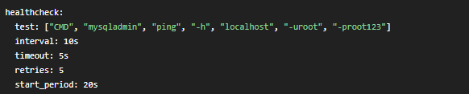

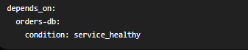

b) Explain in 3–4 lines how this improves reliability but still doesn’t fully replace robust application-level retries.

The MySQL health check ensures that the database is fully initialized before the API starts, reducing startup failures caused by an unavailable database. Using it improves the reliability of the startup process. However, it only handles the initial startup and does not protect against database failures after the application is running. Therefore, the application should still implement retry logic and proper error handling when connecting to the database.

9. During testing, the team wants to scale the API to simulate load.
• a) Write the Docker Compose commands to:
• Start the stack in detached mode.
• Scale orders-api to 3 replicas

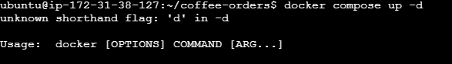

docker ps
docker compose up -d --scale orders-api=3

b) Write the commands to view logs for only orders-api and to view combined logs for all services.

docker compose logs orders-api
docker compose logs -f orders-api

Scenario 4: Data Persistence and Volume Issues

A different team runs MySQL directly with Docker (no Compose yet):
bash
docker run -d --name mysql-db \
-e MYSQL_ROOT_PASSWORD=secret \
mysql:8
After a restart, all data is lost and they escalate to you.

Tasks

10.Explain why the data is lost when the container is removed or recreated with the above command. Relate your answer to how container filesystems work.

The MySQL container stores its data inside the container's writable filesystem. When the container is removed or recreated, this writable layer is also deleted, causing all database data to be lost. Since the command does not use a Docker volume or bind mount, the data is not stored outside the container. Using a named volume allows the database files to persist independently of the container, so the data remains available even after the container is recreated.

11.Write a corrected docker run command that:
• Uses a named volume mysql-data for persistence.
• Exposes MySQL on host port 3307 instead of 3306.
• Uses container name mysql-orders.

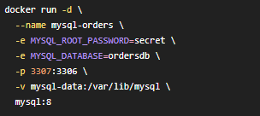

docker ps

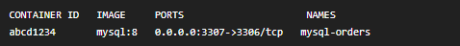

12.A developer wants to inspect the database using the MySQL CLI inside the container.

a) Provide the command to get an interactive MySQL shell inside mysql-orders.

docker exec -it mysql-orders bash
mysql -u root -p

b) Provide a separate command to copy an SQL file (schema.sql) from the host /tmp directory into /docker-entrypointinitdb.d/ inside the container so that MySQL initializes with this schema next time.

docker exec -it mysql-orders ls /docker-entrypoint-initdb.d/
Schema.sql

Scenario 5: Production Release, Rollback and Debugging

Your production host is running a container for org/coffee-api using image tag 2.0. After deployment, error rates spike. The previous version 1.9 was stable.

Tasks

13.You must quickly roll back to 1.9.
a) Assume the container was started via docker run. Write the sequence of commands to stop the current container and start a new one with image org/coffee-api:1.9, keeping the same host port mapping.

docker ps

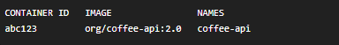

docker stop coffee-api
docker rm coffee-api
docker pull org/coffee-api:1.9

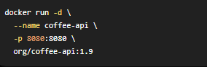
docker ps



b) If this was a Docker Swarm service called coffee-api-svc, write the docker service update command to roll back to 1.9.

docker service update --image org/coffee-api:1.9 coffee-api-svc
docker service ls
docker service ps coffee-api-svc

14.Before rolling back, you need to understand the issue. • List five Docker-level checks you will perform on the running 2.0 container to diagnose the problem (for example: logs, docker inspect, health status, resource usage, environment variables, image history). For each, write the actual command you will use.

docker logs coffee-api
docker inspect coffee-api
docker inspect --format='{{.State.Health.Status}}' coffee-api
docker stats coffee-api



15.The team wants a safer deployment strategy next time.
• In 4–6 lines, explain how using versioned image tags, avoiding latest for production, and using immutable images with CI/CD helps in safe rollouts and fast rollbacks in a DevOps environment.

Using versioned image tags ensures that each deployment uses a specific, known version of the application. Avoiding the tag in production prevents accidental deployments of unintended image versions. Building immutable images through a CI/CD pipeline guarantees that the same tested image is promoted across development, testing, and production environments. This approach makes deployments more reliable, simplifies troubleshooting, and enables fast, predictable rollbacks when issues occur.

Scenario 6: Docker in CI Pipeline (Conceptual–Practical Blend)
Your Git repository for orders-api is integrated with a CI system (GitHub Actions / GitLab CI / Jenkins). For every commit to main, the pipeline should:

1. Build Docker image org/orders-api:
2. Run unit tests in a container
3. Push the image to Docker Hub only if tests pass

Tasks

16.Write a high-level pipeline outline (pseudo-YAML or structured bullets) with stages: build, test, push. Under each stage, specify the Docker command(s) that run there (e.g. docker build, docker run, docker push) and what they do.

docker build -t org/orders-api:<git-sha> .
docker run --rm org/orders-api:<git-sha> npm test
echo "$DOCKER_PASSWORD" | docker login -u "$DOCKER_USERNAME" --password-stdin
docker push org/orders-api:<git-sha>

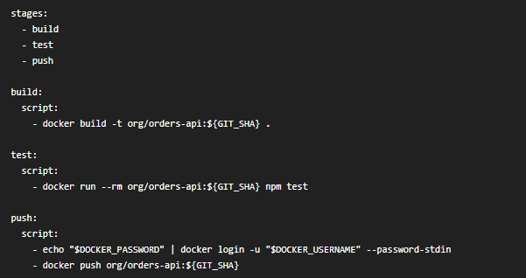

17.The security team insists credentials for Docker Hub must not be stored in the repo.

a) Explain where and how you would store registry credentials securely for the CI runner (2–3 lines).

Docker Hub credentials should not be stored in the source code or repository. Instead, they should be stored as encrypted CI/CD secrets (for example, GitHub Actions Secrets, GitLab CI/CD Variables, or Jenkins Credentials). The CI runner reads these secrets securely during execution and uses them to authenticate with Docker Hub without exposing the username or password in the pipeline code.

b) Mention one tool or step you would add to the pipeline to scan images for vulnerabilities before pushing

trivy image org/orders-api:<git-sha>

